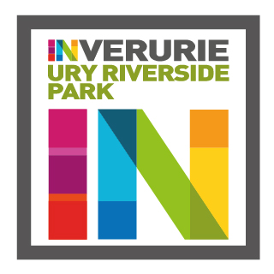
Ury Riverside Park
Trustees’ Annual Report
Period From 1/2/21 to 31/1/22
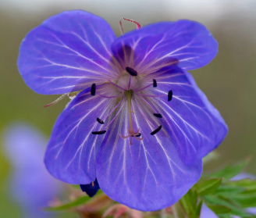

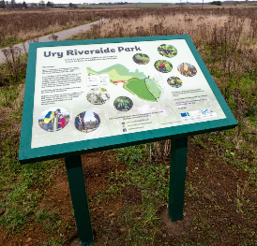
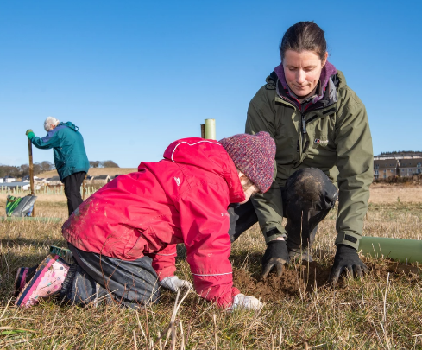
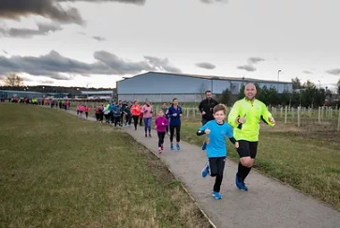
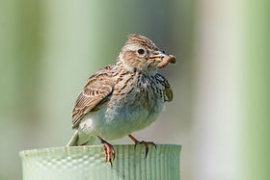
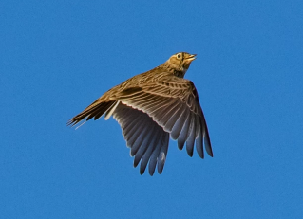
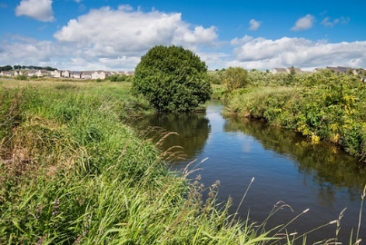
Charity contact information
Ury Riverside Park SCIO
Scottish Charity Number: SC046919
c/o Garioch Area office
Aberdeenshire Council
Gordon House
Blackhall Road
Inverurie, Aberdeenshire
AB51 3WA

e-mail address: ury.riverside@gmail.com

Website: https://www.uryriversidepark.com/
Facebook page: https://www.facebook.com/URY-Riverside-Park-SCIO-213704205739901/
Charity Trustees
Name all of your charity trustees for the period, and the date they left if they were not in post for the whole year

- Martin Auld
- Stephen Hargreaves
- Rod Adams
- John Sangster
- Neil Baillie
- Ian Talboys (Appointed September 2020)
- Paul Douglas (Appointed September 2020)

Objectives and activities

The organisation’s purposes are:
- The advancement and improvement of the area known as Ury Riverside Park, Inverurie
- Develop recreational facilities that are accessible
- Enhance the biodiversity and amenity of the area known as Ury Riverside Park, Inverurie
- To be open and inclusive to appropriate community events
- To do anything else deemed appropriate to meet the aims and objectives of the group.
The Charity’s main activities in the last year has been:
- Continuation land maintenance. Including grass cutting, path edge weed control.
- Repainting of metal storage container.
- Assisting the Council in the control of Giant Hogweed around the park
- Negotiating with property developer about the donation of play equipment to the Park
- Raised a dip in the path near the entrance to prevent the path being waterlogged in wet weather.
- Dug out area around collapsed culvert and use the material to build up the path near the entrance.
- Planting further trees and replacing unsuccessful seedings.
- Bio Blitz
- Regular Litter picking
- Joined re-wilding group
- Worked on proposal to expand the park and buy another area of land in Inverurie.

Structure, governance and management
Type of governing document
The charity operates under its constitution of Ury Riverside Park SCIO

Trustee recruitment and appointment

Achievements and performance
The activities of the trustees have been restricted again this year during the pandemic and this has particularly affected community events which have been restricted to small numbers. However, the group has still had virtual meetings every month and activities around the park have continued where COVID restrictions allowed.

The charity has
- Continued development website of the park website: https://www.uryriversidepark.com
- The trustees and interested local people met, generally each month virtually throughout the year. Minutes of meetings are available.
- Communicated with the community through the Ury Riverside Park Facebook page and quarterly newsletter (online).
- Encouraged the parkrun which has restarted after the Pandemic.

Financial review

Statement of the charity’s policy on reserves
The majority of the costs incurred by the SCIO have been provided by reserves held by Aberdeenshire council. At the start of the year there was an opening balance of £2328.21 and the closing balance was £3378.52. This is an increase of £1050.31 by the end of the year due to a number of donations received. The charity received several donations through Charity Aid Foundation, Cooperative local community fund, Garioch Partnership and Amazon Smile.
There is no current policy for the reserves as yet.

Details of any deficit
There is no deficit

Donated facilities and services
None

Future plans
In the next year the charity intends to:
- Build a granite entrance to the park from Oldmeldrum road subject to the necessary construction funding (the granite has already been acquired).
- Install drainage on the main tarmac path between the entrance and the bridge to prevent a build up of water next to the path from running across the path.
- Make further efforts to continue the eradication of Giant Hogweed within the park programme with the INNS and Aberdeenshire council.
- Oversee plans for new footbridge bridge and connecting path through the park as part of the Meldrum Megway. Although utilising the park this programme is not managed by the charity so timing is uncertain.
- Complete the current plans and seek further funding for the extension of an all-abilities children’s play area.
- Further develop funding for ongoing maintenance of the park.
- Maintain the park vegetation for the benefit of people and wildlife
- Undertake programme of regular on-site litter collection
- Seek to monitor park usage by the local community
- Pursue further opportunities for extensions to the park area
- Seek new trustees and more members from the community.
- Continue to support the very popular Ury Riverside park run event.

Declaration
Signed on behalf of the charity trustees:

Stephen Hargreaves
Print name
Treasurer
Designation
1/5/22
Date

